create 2 EC2 instance on 2 different regions and install nginx using terraform script

we define two aws_provider blocks, one for the us-east-1 region (aliased as us-east) and another for the ap-south-1 region (aliased as mumbai). We then create two aws_instance resources, one for each region, and specify the corresponding provider attribute.

Security groups are created in each region web1 & web2 to provide inbound and outbound traffic.

Key pair is created in each region separately.

Default VPC is used in both regions (us-east-1 & ap-south-1).

Nginx installation steps are provided in the user_data attribute.

# script for nginx installation

   user_data = <<-EOF

                  #!/bin/bash

                  sudo yum install -y nginx

                  sudo systemctl start nginx

                  sudo systemctl enable nginx

                  EOF

Terraform will create the resources in parallel, using the respective providers for each region.



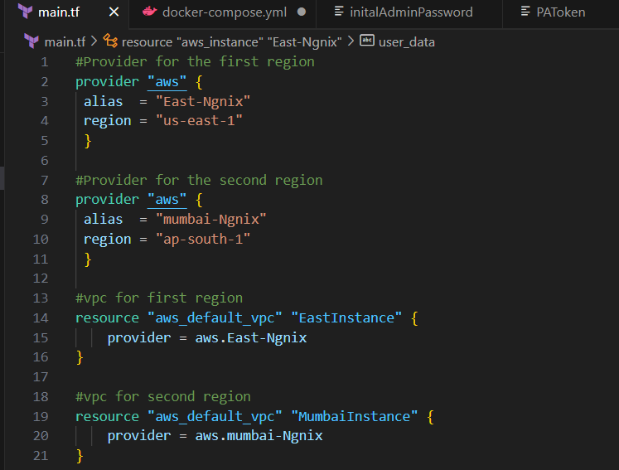

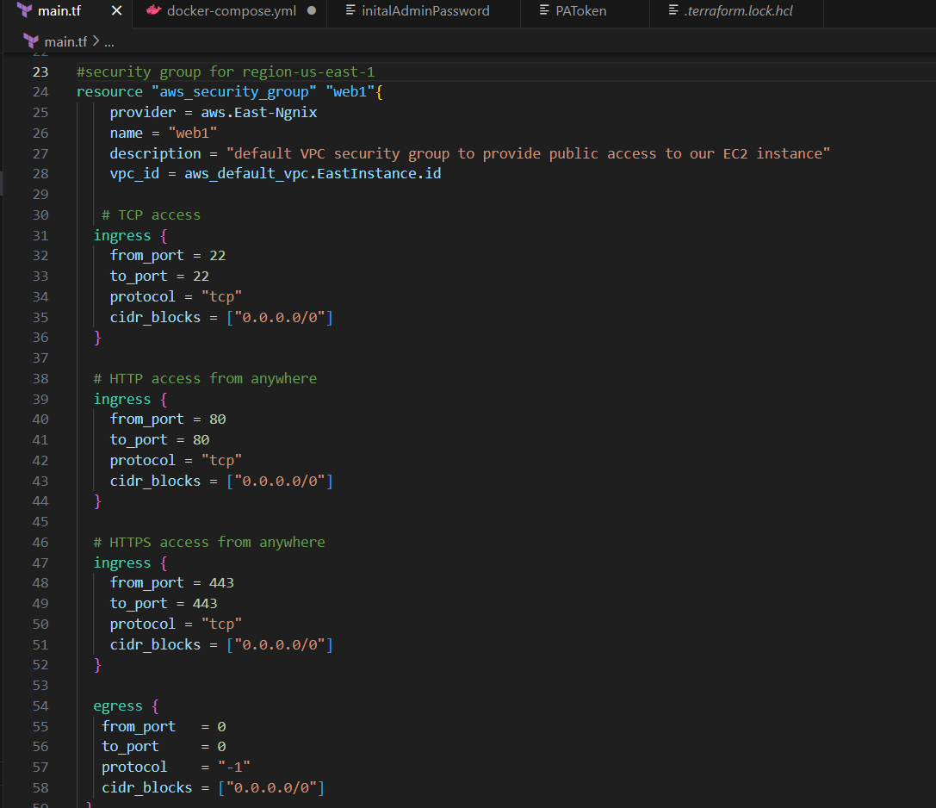

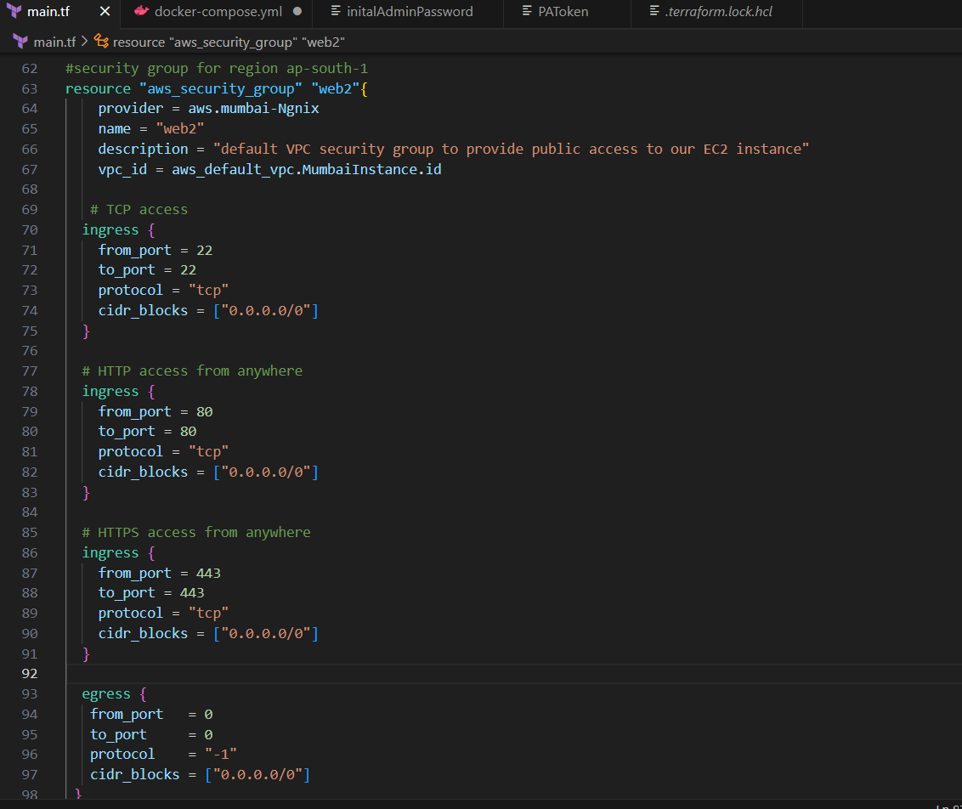

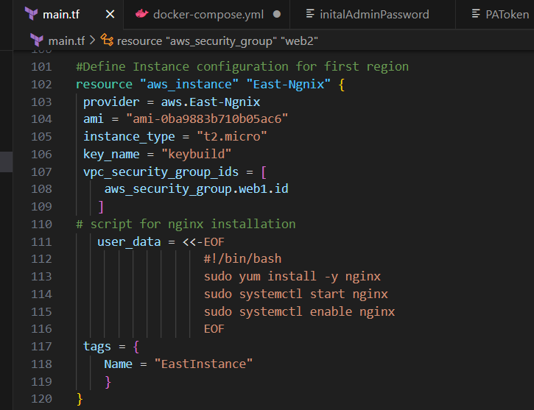

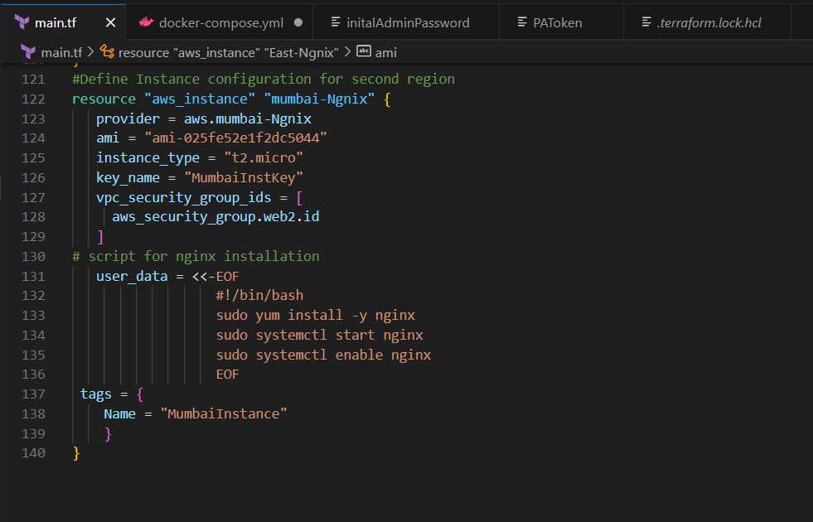

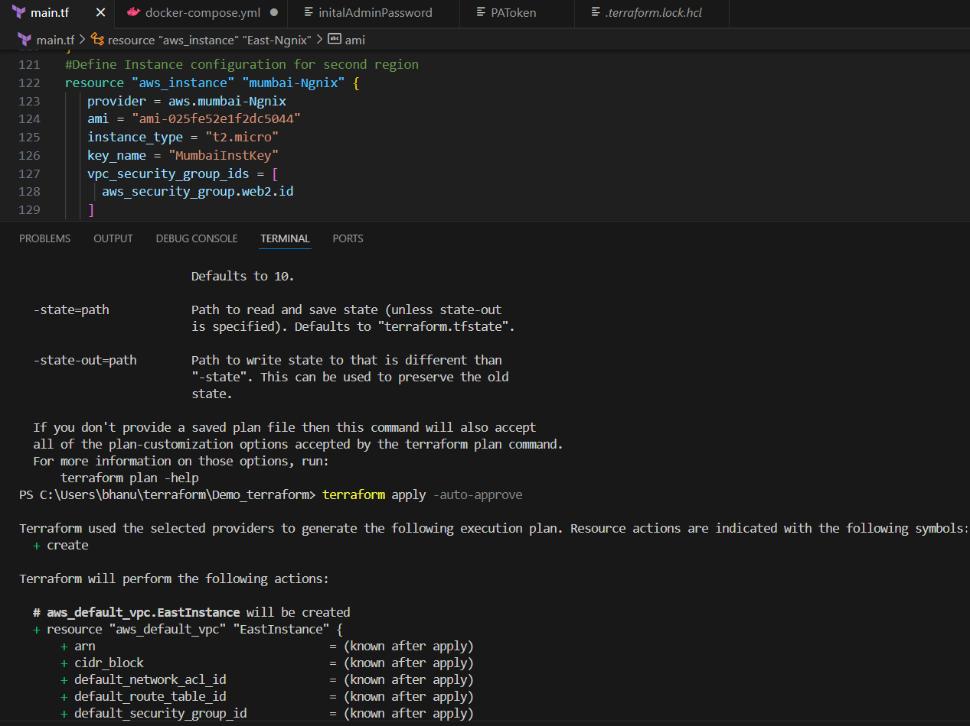

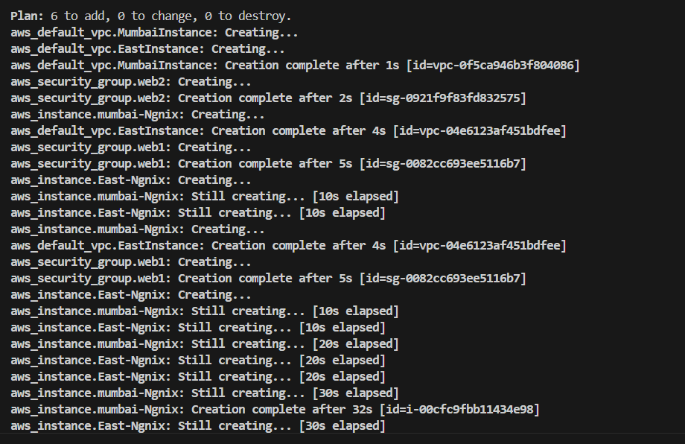

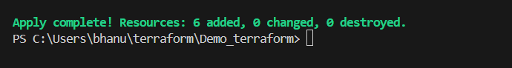

Instance from us-east-1 region is created with tag name as **EastInstance**.

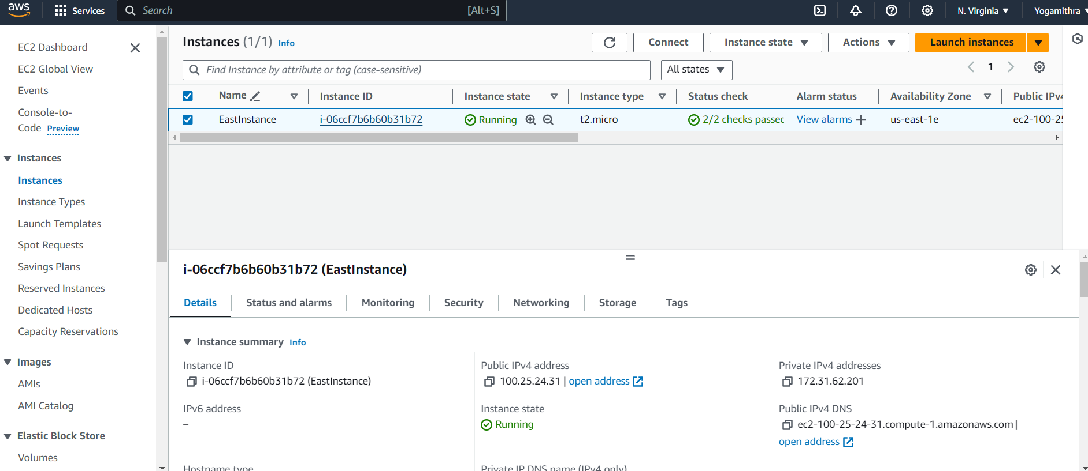

Instance from ap-south-1 region is created with tag name as **MumbaiInstance**.

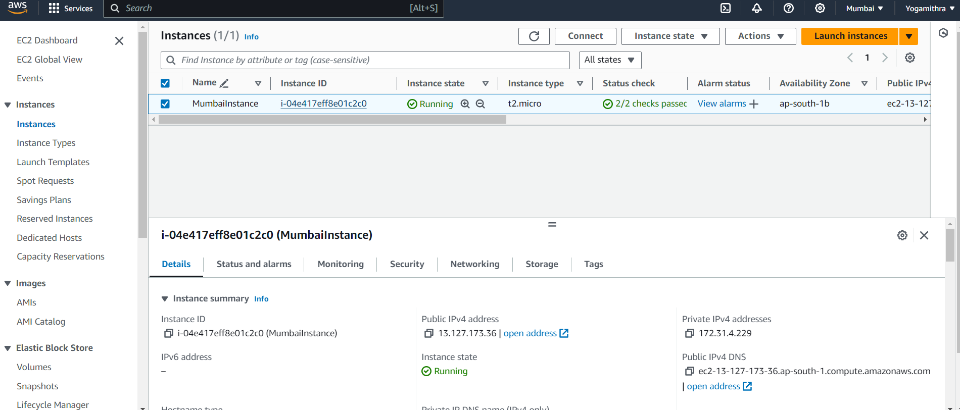

Nginx installation verification

Us-east-1

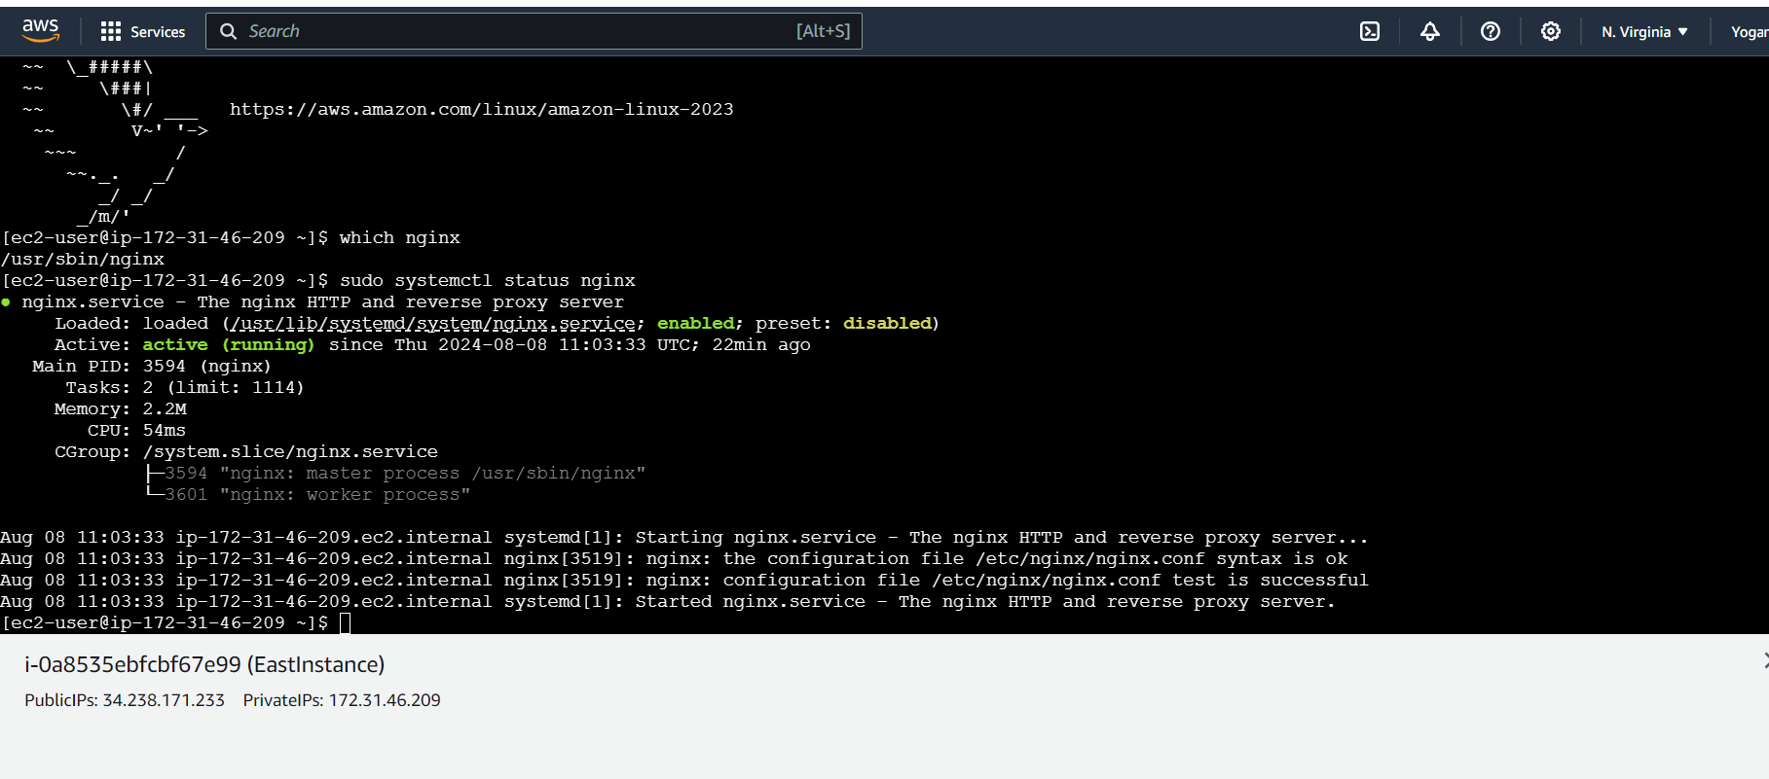

ap-south-1

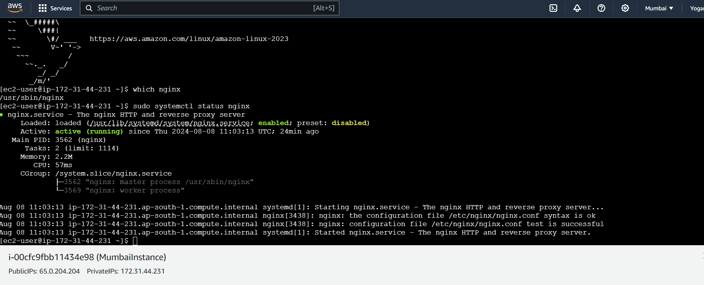

Terraform destroy

